(1) 2020 Countryside Tank MC-331, LP Transport 14,400 Gallon (250 PSI) Quad-axle

Western Cascade
Pat Malara
Stock Trailer
Ready for Delivery
Pat Malara
206-972-1888 Cell

Approximate weight: 30,650 lbs.

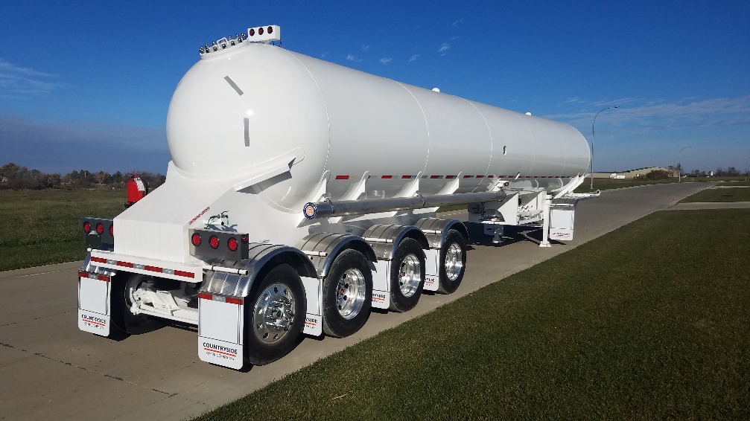

Sample Photo

Pressure Vessel: 14,400 US water gallons 86.5” ID LP Transport vessel built with SA-517 QT steel, quad-axle configuration. Built in accordance with ASME code section VIII, Division I and D.O.T. specifications MC-331

Design Pressure: 250 PSI

Operating Temp: -20 – 125 degrees Fahrenheit

Product Service: Refined LPG

Baffles: Three sets of 1/4” Grade 5454 Aluminum baffle

Sub frame: Sub-frame constructed of ¼” stainless steel.

Suspension: 3, Hendrickson Intraax 23k air ride suspensions for front 3 suspensions; 77.5” track with parallel spindles. Rear suspension to be a Hendrickson 13.5k steerable lift axle. Hendrickson lift for front axle. 60” spacing between front 3 axles. 49” axle spread between 3rd axle and rear steerable.

ABS: Wabco combination 4S/2M ABS

Brakes: 16.5” (x) 7” standard duty, centrifuge brake drums

Wheels: (14) Aluminum wheels with mill finish

Tires: (14) Goodyear Marathon RSS 11R22.5 tires

Fenders: Double contour aluminum front fenders. Aluminum individual rear fenders with mud flaps for each wheel.

Mud Flaps: Anti-sail mud flaps mounted to front fenders and rear wheels of trailer.

Bumper: D.O.T. compliant bumper.

Hose Tubes: (2) 8” (x) 21’ aluminum hose tubes. One door per tube. (Unpainted)

Landing Gear: Holland model 50,000 lb. two-speed roll-down landing gear with 10” x 10” sand shoes. Crank located on street side.

Kingpin: Adjustable king pin plate, 2.5” increments

Lighting: DOT approved Truck lite LED lighting with mid-ship turn signals and stainless steel rear light boxes.

Electrical: System: Twelve-volt electrical system, lights, and reflectors, all furnished in accordance with D.O.T. regulations. Electrical and air connections are custom sealed.

Piping: Openings include a pump flange, liquid flange, and a separate spray fill and vapor flange. Openings in the following order from front to rear: Pump, Liquid, Spray-fill, Vapor. (4 total)

Pump: Marshall Excelsior 4” flanged air actuated internal valve, 4” Corken pump. Pump set for hydraulic drive. Hydraulic lines run under belly of trailer and terminate out the front of the front sub- frame. (2) 2” MEC flanged globe valves and terminating both street and curbside with 3.25” (x) 2” brass ACME adapters and caps.

Vapor: 3” Flanged vapor opening piped with 3” MEC air actuated internal valve; (2) 2” MEC flanged globe valves and terminating both street and curbside with 3.25 (x) 2” with a 1.75”x2” reducer and brass ACME adapters and caps.

Spray-fill: 3” Flanged spray-fill opening piped with 3” MEC air actuated internal valve; (2) 2” MEC flanged globe valves and terminating both street and curbside with 3.25 (x) 2” brass ACME adapters and caps.

Liquid: 3” Flanged liquid withdrawal opening piped with 3” MEC air actuated internal valve, (2) 2” MEC flanged globe valves and terminating both street and curbside with 3.25”x2” brass ACME adapters and caps

HM-225/Passive Customer supplied smart hoses.

Relief Valves: Marshall Excelsior threaded 3” 250 PSI relief valves. Relief valves protected with roll over protection.

Blow Downs: Blow down system: Blow down with .5” stainless steel ¼ turn ball valve furnished for each manual valve, including auxiliary intake piped to top of trailer with ½" stainless steel tubing.

Valve Controls: Air operated valve controls to be located in the cage area. Valve control box located curb side. (customer can select street side)

Safety Remotes: Air operators at the left front and rear right of transport. D.O.T. Emergency Shut-off markings provided

Brake Interlock: Brake interlocks installed with Dixie gates.

Gauges: Marshall Excelsior visual percentage gauge, (4) fixed outage gauges set at 83%, 85%, 87%, 90%, 0-400# liquid filled pressure gauge, and thermometer all installed in recess wells curbside.

Fire Extinguisher: Fire Extinguisher bracket provided by Countryside Tank. Located on street side on rear sub-frame. Can be moved to other location if desired by customer. Customer supplied fire extinguisher.

Paint: Sandblasted, primed and painted. PPG Spectracron 560 wet on wet primer and Spectracron 380 series poly-lothane HS exterior polyurethane top coat. Trailer painted all white in color.

Other items: Document holder mounted on street side landing gear, conspicuity tape per D.O.T., Marshall-Excelsior (MEC) chock blocks (yellow) and holder mounted to front of rear sub-frame. (2) Aluminum air tanks. Add pad to center of front head and swing arm to pad for holding hoses. Aluminum slide-in type placard holders all 4 sides.

Terms: A 30% deposit will be invoiced upon receipt of a signed order. Balance due upon completion. Price valid for 30 days.
State & local taxes not included. Title & license fees not included.

Delivery: Customer pick-up required at our production facility located at 1525 E Eddy Saylor Pkwy, Osceola, Iowa 50213.
Quotes for delivery to the customer’s location are available upon request.

Accepted By: Date:

Title: ___________________

